Project Report Format

1.Introduction

Overview:-

An online shoe industry great company idea due to significant market expansion in the footwear market. Many enterneur are highly excited to start

their bussiness first ,but even the most enthusiastic minds find it hard to deal with real world sales obstacles.The most importnant hurdle when

it comes to selling shoes online returns.They are therefold more than in the general feild of eCommerce in footwear than 35%.As an owner of an eCommerce

store,it is the most demanding component of an online bussiness to deal with product returns.You need a should approch to avoid such issue,from the choice

of a type shoe to an excellent experience on your site.

Purpose:-

*product in high demand

we said,as our boots wear off out of style,consumer will always require new shoes.Nearly every adult buys at least 2 pairs of footwear throughtout the year,accordingly

to data.And some of us regard the buying of shoes as a means to relax.

*Good revenue

shoe shops creat money and nice money so that you have a good income.

*Selection of a range

the composition of your spectrum is free so that u complete with other market players more successfully

*No costly equipment must be purchased

Online shoes do not need manufacturing facilities.

2.Literature survive

Exiting problem:-

there were many problems

*Quality

*Logistical and delivery issues

*Digital payment issues

*Unclear return policies

Proposed solution:-

*Executive summary

*company overview

*industry analysis

*customer analysis

*compitative analysis

*Marketing plan

*operations plan

*Management team

3.Theoritical analysis

Block diagram:

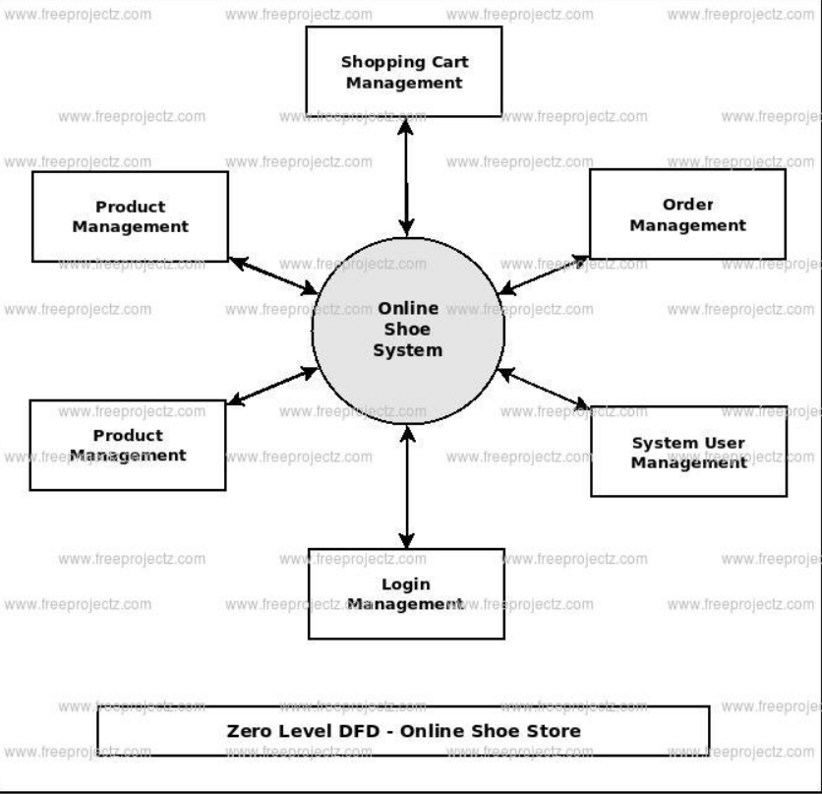

**Hardware/Software designing**:-

Size,width and colour matrix

Accessory coordination

Customer relationship management

Customer loyalty program

Prescription management

Upc database

Packages sales

**Result:-**

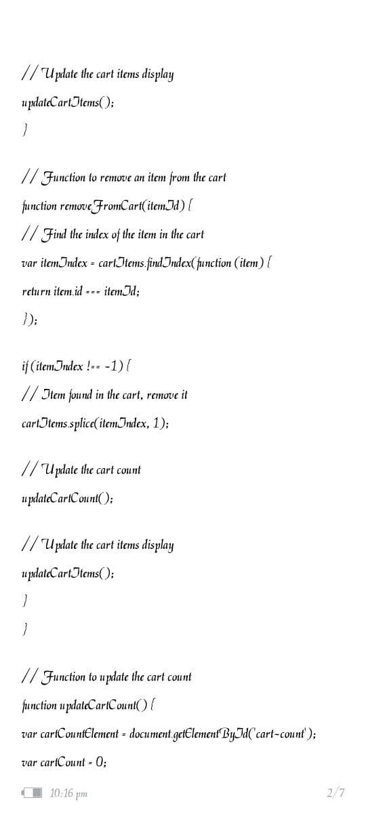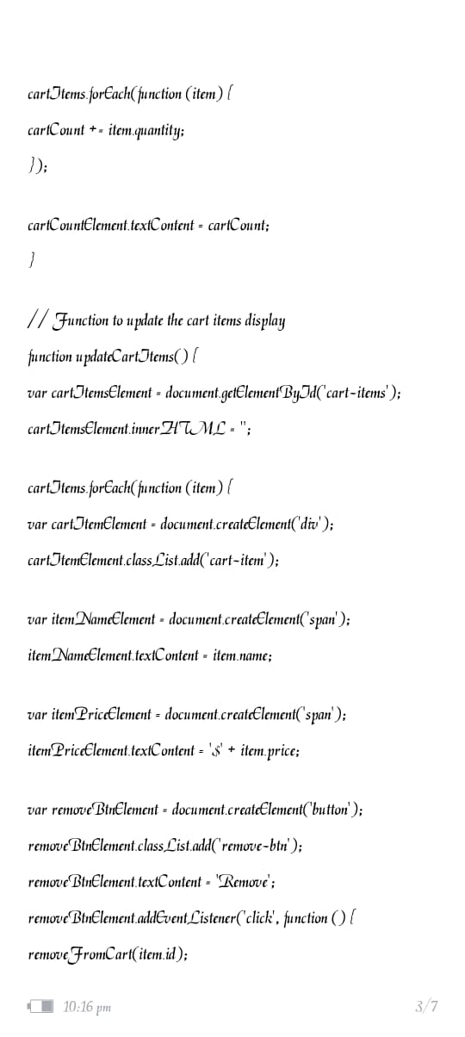

5.Advantages and Disadvantages:-

*resale operations means limited risk

*Consider brand requirements

*Multi-market sales opportunities

*Simple business operations

6**.Application**

Shoe shop is a nicely designed and developed mobile application UI kit developed using flutter with animations.

7**.Conclusion**

E-commerce still represents one of the business methods that take advantage if done the right way, even if the stock market and com .It still able to survive and receive high transaction.

8**.Fture scope**

The global footwear market size was valued at USD 454875 44 million in 2022 and is expected to expand at CAGR OF 3.6 Percent during the forecast period.